Two-Factor Authentication using Google Authenticator in Asp.Net MVC

**Step 1**

Create a new project in Visual Studio, select an **ASP.NET Web Application (.Net Framework),** and press the Next button.

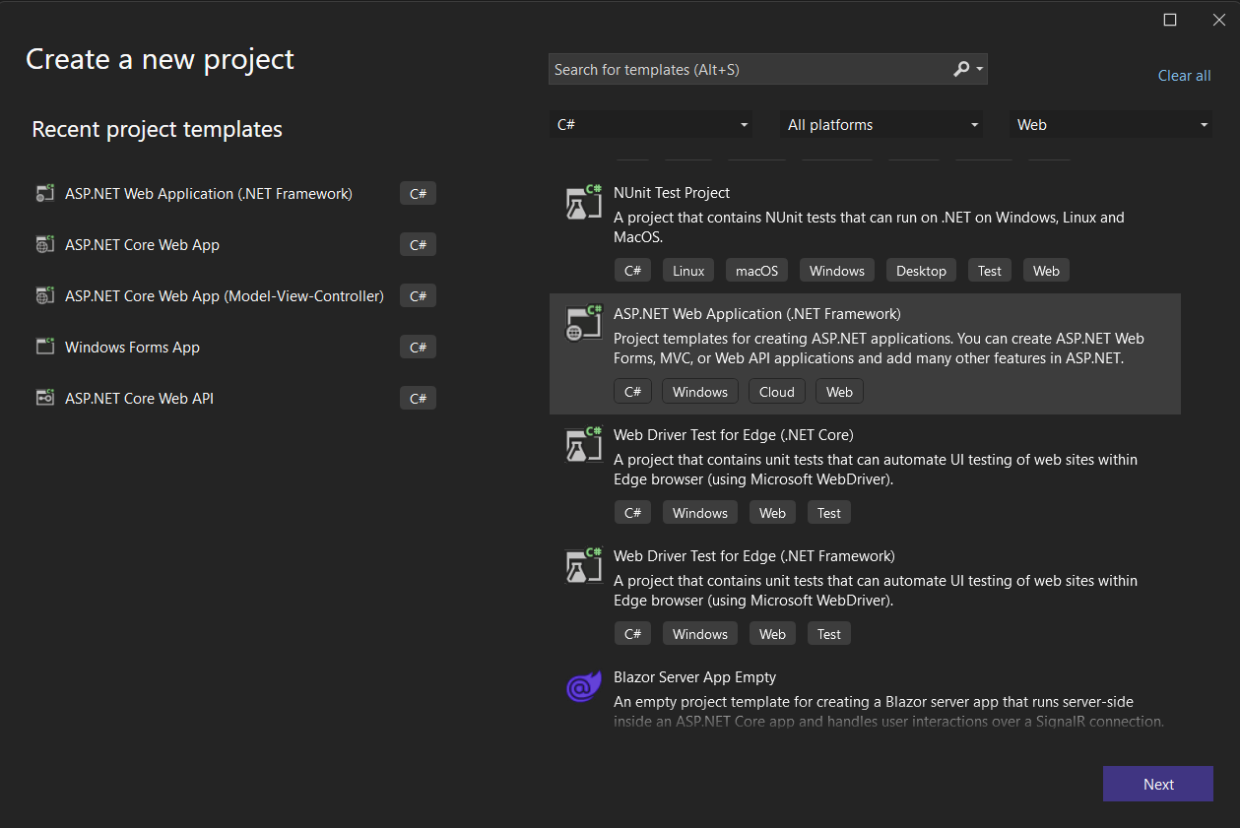

**Step 2**

Give the project a name, select the save location folder, and click on the Create button.

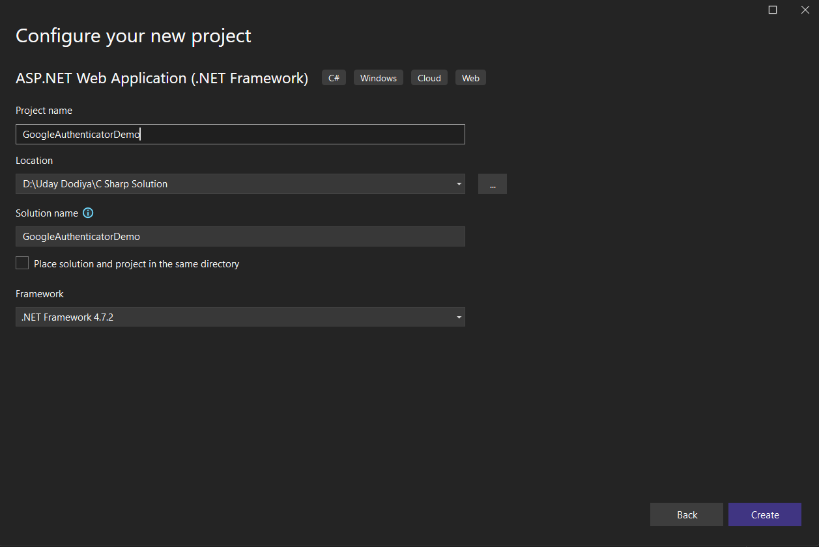

**Step 3**

Select **MVC**Option for project type and click on the Create button. Now your project is created.

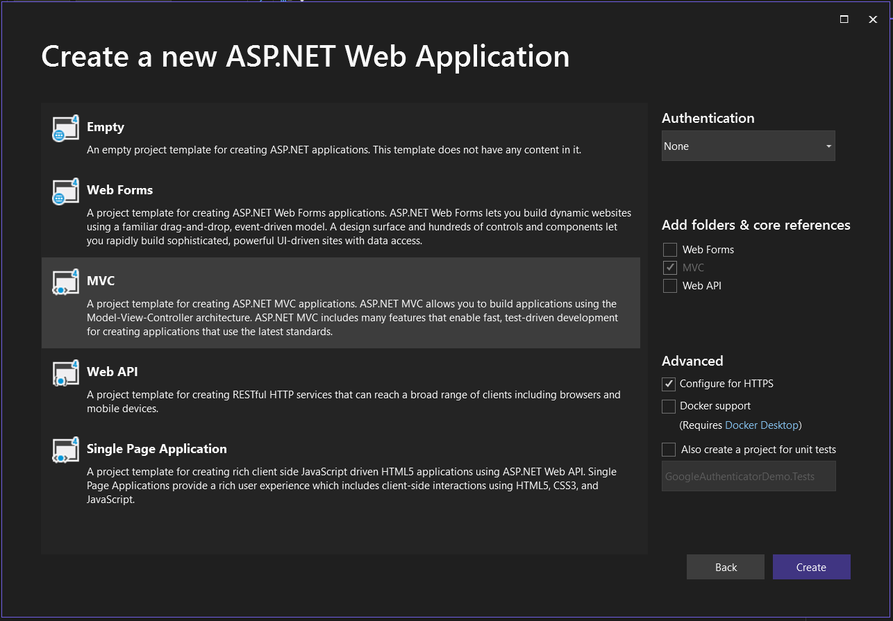

**Step 4**

Add the Google.Authenticator package from NuGet.

Go to Tools Menu - **NuGet Package Manager** - Manage NuGetPackages For Solution- Search for **Google.Authenticator** > Install > Close.

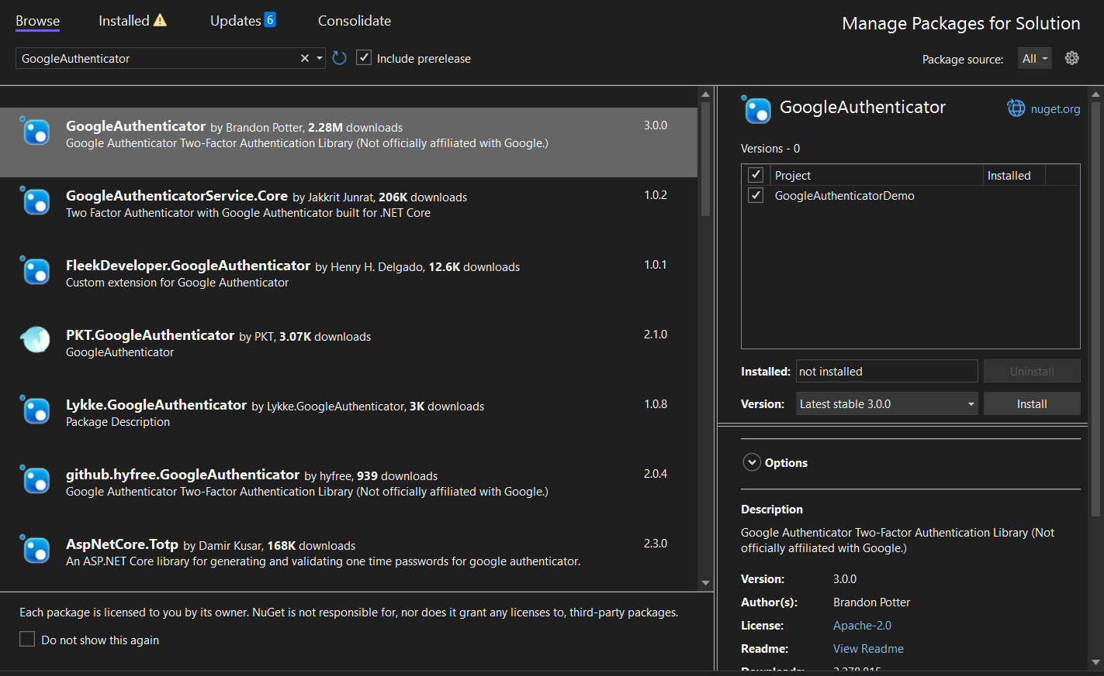

**Step 5**

Add the Model class **LoginModel.cs** under **Model Folder**for login details that stores the username and password.

using System;

using System.Collections.Generic;

using System.Linq;

using System.Web;

namespace GoogleAuthenticatorDemo.Models

{

public class LoginModel

{

public string UserName { get; set; }

public string Password { get; set; }

}

}

C#

Copy

**Step 6**

Add the Google Authentication Private Key In **Web.Config** File under <appSettings>.

This key is not fixed; you can create it yourself with any character combination.

Any character combination use as private key in google authenticator.

<appSettings>

<add key="webpages:Version" value="3.0.0.0" />

<add key="webpages:Enabled" value="false" />

<add key="ClientValidationEnabled" value="true" />

<add key="UnobtrusiveJavaScriptEnabled" value="true" />

<add key="GoogleAuthKey" value="U1d2A3y4" />

</appSettings>

BASIC

Copy

**Step 7**

Create a **Login action**method in your controller; in my case, it's HomeController.

public ActionResult Login()

{

Session["UserName"] = null;

Session["IsValidTwoFactorAuthentication"] = null;

return View();

}

C#

Copy

**Step 8**

Right click on the **Login action** method and select **Add View Option**, and then select the following: Then click the Add Button button to add a view for this action method.

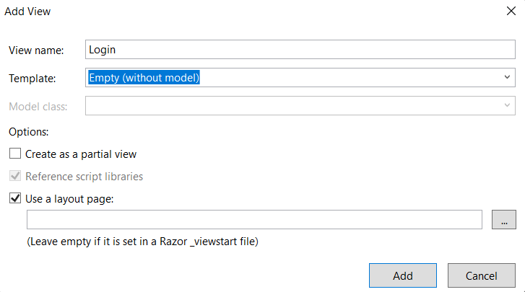

Now a new file is created under View > Home > Login.cshtml.

**Step 9**

Add the following code into **Login.cshtml**:

@model GoogleAuthenticatorDemo.Models.LoginModel

@{

ViewBag.Title = "Login";

}

<[center](https://webplatform.github.io/docs/html/elements/center)>

<[h2](https://webplatform.github.io/docs/html/elements/h2)>Login Page</[h2](https://webplatform.github.io/docs/html/elements/h2)>

@if (ViewBag.Status == null || !ViewBag.Status)

{

<[div](https://webplatform.github.io/docs/html/elements/div)>@ViewBag.Message</[div](https://webplatform.github.io/docs/html/elements/div)>

<[div](https://webplatform.github.io/docs/html/elements/div)>

@using (Html.BeginForm())

{

<[div](https://webplatform.github.io/docs/html/elements/div) [class](https://webplatform.github.io/docs/html/attributes/class)="form-group">

<[label](https://webplatform.github.io/docs/html/elements/label) [for](https://webplatform.github.io/docs/html/attributes/for)="UserName">UserName : </[label](https://webplatform.github.io/docs/html/elements/label)>

@Html.TextBoxFor(a => a.UserName, new { @class = "form-control" })

</[div](https://webplatform.github.io/docs/html/elements/div)>

<[div](https://webplatform.github.io/docs/html/elements/div) [class](https://webplatform.github.io/docs/html/attributes/class)="form-group">

<[label](https://webplatform.github.io/docs/html/elements/label) [for](https://webplatform.github.io/docs/html/attributes/for)="Password">Password : </[label](https://webplatform.github.io/docs/html/elements/label)>

@Html.TextBoxFor(a => a.Password, new { @class = "form-control", type = "password" })

</[div](https://webplatform.github.io/docs/html/elements/div)>

<[input](https://webplatform.github.io/docs/html/elements/input) [type](https://webplatform.github.io/docs/html/attributes/type)="submit" [value](https://webplatform.github.io/docs/html/attributes/value)="Login" [class](https://webplatform.github.io/docs/html/attributes/class)="btn btn-default" />

}

</[div](https://webplatform.github.io/docs/html/elements/div)>

}

else

{

<[div](https://webplatform.github.io/docs/html/elements/div)>@ViewBag.Message</[div](https://webplatform.github.io/docs/html/elements/div)>

<[div](https://webplatform.github.io/docs/html/elements/div)>

<[img](https://webplatform.github.io/docs/html/elements/img" \t "_blank) [src](https://webplatform.github.io/docs/html/attributes/src)="@ViewBag.BarcodeImageUrl" [width](https://webplatform.github.io/docs/html/attributes/width)="300" [height](https://webplatform.github.io/docs/html/attributes/height)="300" />

</[div](https://webplatform.github.io/docs/html/elements/div)>

<[div](https://webplatform.github.io/docs/html/elements/div)>

Manual Setup Code : @ViewBag.SetupCode

</[div](https://webplatform.github.io/docs/html/elements/div)>

<[div](https://webplatform.github.io/docs/html/elements/div)>

@using (Html.BeginForm("TwoFactorAuthenticate", "Home", FormMethod.Post))

{

<[input](https://webplatform.github.io/docs/html/elements/input) [type](https://webplatform.github.io/docs/html/attributes/type)="text" [name](https://webplatform.github.io/docs/html/attributes/name)="CodeDigit" />

<[input](https://webplatform.github.io/docs/html/elements/input) [type](https://webplatform.github.io/docs/html/attributes/type)="submit" [class](https://webplatform.github.io/docs/html/attributes/class)="btn btn-success" />

}

</[div](https://webplatform.github.io/docs/html/elements/div)>

}

</[center](https://webplatform.github.io/docs/html/elements/center)>

Markup

Copy

**Step 10**

Create a**Post**type **Login Action method** in your controller and add the following code:

[HttpPost]

public ActionResult Login(LoginModel login)

{

bool status = false;

if (Session["Username"] == null || Session["IsValidTwoFactorAuthentication"] == null || !(bool) Session["IsValidTwoFactorAuthentication"])

{

string googleAuthKey = WebConfigurationManager.AppSettings["GoogleAuthKey"];

string UserUniqueKey = (login.UserName + googleAuthKey);

//Take UserName And Password As Static - Admin As User And 12345 As Password

if (login.UserName == "Admin" && login.Password == "12345")

{

Session["UserName"] = login.UserName;

//Two Factor Authentication Setup

TwoFactorAuthenticator TwoFacAuth = new TwoFactorAuthenticator();

var setupInfo = TwoFacAuth.GenerateSetupCode("UdayDodiyaAuthDemo.com", login.UserName, ConvertSecretToBytes(UserUniqueKey, false), 300);

Session["UserUniqueKey"] = UserUniqueKey;

ViewBag.BarcodeImageUrl = setupInfo.QrCodeSetupImageUrl;

ViewBag.SetupCode = setupInfo.ManualEntryKey;

status = true;

}

}

else

{

return RedirectToAction("Index");

}

ViewBag.Status = status;

return View();

}

C#

Copy

**Step 11**

Create the **ConvertSecretToBytes**function in the controller.

private static byte[] ConvertSecretToBytes(string secret, bool secretIsBase32) =>

secretIsBase32 ? Base32Encoding.ToBytes(secret) : Encoding.UTF8.GetBytes(secret);

C#

Copy

**Step 12**

Create a **TwoFactorAuthenticate**Action action method for your controller.

public ActionResult TwoFactorAuthenticate()

{

var token = Request["CodeDigit"];

TwoFactorAuthenticator TwoFacAuth = new TwoFactorAuthenticator();

string UserUniqueKey = Session["UserUniqueKey"].ToString();

bool isValid = TwoFacAuth.ValidateTwoFactorPIN(UserUniqueKey, token, false);

if (isValid)

{

HttpCookie TwoFCookie = new HttpCookie("TwoFCookie");

string UserCode =Convert.ToBase64String(MachineKey.Protect(Encoding.UTF8.GetBytes(UserUniqueKey)));

Session["IsValidTwoFactorAuthentication"] = true;

return RedirectToAction("Index");

}

ViewBag.Message = "Google Two Factor PIN is expired or wrong";

return RedirectToAction("Login");

}

C#

Copy

**Step 13**

Create a **Logoff**Action Method in your controller to handle the logout action.

public ActionResult Logoff()

{

Session["UserName"] = null;

Session["IsValidTwoFactorAuthentication"] = null;

return RedirectToAction("Login");

}

C#

Copy

**Step 14**

To handle an **unauthorised login**, add the following condition to all of your action methods, which in my case are three method.

public ActionResult Index()

{

if (Session["Username"] == null || Session["IsValidTwoFactorAuthentication"] == null || !(bool)Session["IsValidTwoFactorAuthentication"])

{

return RedirectToAction("Login");

}

return View();

}

public ActionResult About()

{

if (Session["Username"] == null || Session["IsValidTwoFactorAuthentication"] == null || !(bool)Session["IsValidTwoFactorAuthentication"])

{

return RedirectToAction("Login");

}

ViewBag.Message = "Your application description page.";

return View();

}

public ActionResult Contact()

{

if (Session["Username"] == null || Session["IsValidTwoFactorAuthentication"] == null || !(bool)Session["IsValidTwoFactorAuthentication"])

{

return RedirectToAction("Login");

}

ViewBag.Message = "Your contact page.";

return View();

}

C#

Copy

**Final HomeController.cs File**

using Google.Authenticator;

using GoogleAuthenticatorDemo.Models;

using System;

using System.Collections.Generic;

using System.Linq;

using System.Text;

using System.Web;

using System.Web.Configuration;

using System.Web.Mvc;

using System.Web.Security;

namespace GoogleAuthenticatorDemo.Controllers

{

public class HomeController : Controller

{

public ActionResult Index()

{

if (Session["Username"] == null || Session["IsValidTwoFactorAuthentication"] == null || !(bool)Session["IsValidTwoFactorAuthentication"])

{

return RedirectToAction("Login");

}

return View();

}

public ActionResult About()

{

if (Session["Username"] == null || Session["IsValidTwoFactorAuthentication"] == null || !(bool)Session["IsValidTwoFactorAuthentication"])

{

return RedirectToAction("Login");

}

ViewBag.Message = "Your application description page.";

return View();

}

public ActionResult Contact()

{

if (Session["Username"] == null || Session["IsValidTwoFactorAuthentication"] == null || !(bool)Session["IsValidTwoFactorAuthentication"])

{

return RedirectToAction("Login");

}

ViewBag.Message = "Your contact page.";

return View();

}

public ActionResult Login()

{

Session["UserName"] = null;

Session["IsValidTwoFactorAuthentication"] = null;

return View();

}

[HttpPost]

public ActionResult Login(LoginModel login)

{

bool status = false;

if (Session["Username"] == null || Session["IsValidTwoFactorAuthentication"] == null || !(bool)Session["IsValidTwoFactorAuthentication"])

{

string googleAuthKey = WebConfigurationManager.AppSettings["GoogleAuthKey"];

string UserUniqueKey = (login.UserName + googleAuthKey);

//Take UserName And Password As Static - Admin As User And 12345 As Password

if (login.UserName == "Admin" && login.Password == "12345")

{

Session["UserName"] = login.UserName;

//Two Factor Authentication Setup

TwoFactorAuthenticator TwoFacAuth = new TwoFactorAuthenticator();

var setupInfo = TwoFacAuth.GenerateSetupCode("UdayDodiyaAuthDemo.com", login.UserName, ConvertSecretToBytes(UserUniqueKey, false), 300);

Session["UserUniqueKey"] = UserUniqueKey;

ViewBag.BarcodeImageUrl = setupInfo.QrCodeSetupImageUrl;

ViewBag.SetupCode = setupInfo.ManualEntryKey;

status = true;

}

}

else

{

return RedirectToAction("Index");

}

ViewBag.Status = status;

return View();

}

private static byte[] ConvertSecretToBytes(string secret, bool secretIsBase32) =>

secretIsBase32 ? Base32Encoding.ToBytes(secret) : Encoding.UTF8.GetBytes(secret);

public ActionResult TwoFactorAuthenticate()

{

var token = Request["CodeDigit"];

TwoFactorAuthenticator TwoFacAuth = new TwoFactorAuthenticator();

string UserUniqueKey = Session["UserUniqueKey"].ToString();

bool isValid = TwoFacAuth.ValidateTwoFactorPIN(UserUniqueKey, token, false);

if (isValid)

{

HttpCookie TwoFCookie = new HttpCookie("TwoFCookie");

string UserCode = Convert.ToBase64String(MachineKey.Protect(Encoding.UTF8.GetBytes(UserUniqueKey)));

Session["IsValidTwoFactorAuthentication"] = true;

return RedirectToAction("Index");

}

ViewBag.Message = "Google Two Factor PIN is expired or wrong";

return RedirectToAction("Login");

}

public ActionResult Logoff()

{

Session["UserName"] = null;

Session["IsValidTwoFactorAuthentication"] = null;

return RedirectToAction("Login");

}

}

}

C#

Copy

**Step 15**

All pages display the user's name and the option to log out. So add that code to the **\_Layout.cshtml** page, and your \_Layout.cshtml should now look like this:

<!DOCTYPE html>

<[html](https://webplatform.github.io/docs/html/elements/html)>

<[head](https://webplatform.github.io/docs/html/elements/head)>

<[meta](https://webplatform.github.io/docs/html/elements/meta) [charset](https://webplatform.github.io/docs/html/attributes/charset)="utf-8" />

<[meta](https://webplatform.github.io/docs/html/elements/meta) [name](https://webplatform.github.io/docs/html/attributes/name)="viewport" [content](https://webplatform.github.io/docs/html/attributes/content)="width=device-width, initial-scale=1.0">

<[title](https://webplatform.github.io/docs/html/elements/title)>@ViewBag.Title - My ASP.NET Application</[title](https://webplatform.github.io/docs/html/elements/title)>

@Styles.Render("~/Content/css")

@Scripts.Render("~/bundles/modernizr")

</[head](https://webplatform.github.io/docs/html/elements/head)>

<[body](https://webplatform.github.io/docs/html/elements/body)>

<[div](https://webplatform.github.io/docs/html/elements/div) [class](https://webplatform.github.io/docs/html/attributes/class)="navbar navbar-inverse navbar-fixed-top">

<[div](https://webplatform.github.io/docs/html/elements/div) [class](https://webplatform.github.io/docs/html/attributes/class)="container">

<[div](https://webplatform.github.io/docs/html/elements/div) [class](https://webplatform.github.io/docs/html/attributes/class)="navbar-header">

<[button](https://webplatform.github.io/docs/html/elements/button) [type](https://webplatform.github.io/docs/html/attributes/type)="button" [class](https://webplatform.github.io/docs/html/attributes/class)="navbar-toggle" data-toggle="collapse" data-target=".navbar-collapse" [title](https://webplatform.github.io/docs/html/attributes/title)="more options">

<[span](https://webplatform.github.io/docs/html/elements/span) [class](https://webplatform.github.io/docs/html/attributes/class)="icon-bar"></[span](https://webplatform.github.io/docs/html/elements/span)>

<[span](https://webplatform.github.io/docs/html/elements/span) [class](https://webplatform.github.io/docs/html/attributes/class)="icon-bar"></[span](https://webplatform.github.io/docs/html/elements/span)>

<[span](https://webplatform.github.io/docs/html/elements/span) [class](https://webplatform.github.io/docs/html/attributes/class)="icon-bar"></[span](https://webplatform.github.io/docs/html/elements/span)>

</[button](https://webplatform.github.io/docs/html/elements/button)>

@Html.ActionLink("Application name", "Index", "Home", new { area = "" }, new { @class = "navbar-brand" })

</[div](https://webplatform.github.io/docs/html/elements/div)>

<[div](https://webplatform.github.io/docs/html/elements/div) [class](https://webplatform.github.io/docs/html/attributes/class)="navbar-collapse collapse">

<[ul](https://webplatform.github.io/docs/html/elements/ul) [class](https://webplatform.github.io/docs/html/attributes/class)="nav navbar-nav">

<[li](https://webplatform.github.io/docs/html/elements/li)>@Html.ActionLink("Home", "Index", "Home")</[li](https://webplatform.github.io/docs/html/elements/li)>

<[li](https://webplatform.github.io/docs/html/elements/li)>@Html.ActionLink("About", "About", "Home")</[li](https://webplatform.github.io/docs/html/elements/li)>

<[li](https://webplatform.github.io/docs/html/elements/li)>@Html.ActionLink("Contact", "Contact", "Home")</[li](https://webplatform.github.io/docs/html/elements/li)>

</[ul](https://webplatform.github.io/docs/html/elements/ul)>

@if (@HttpContext.Current.Session["UserName"] != null && @HttpContext.Current.Session["IsValidTwoFactorAuthentication"] != null)

{

[if(bool.Parse(@HttpContext.Current.Session](mailto:if(bool.Parse(@HttpContext.Current.Session)["IsValidTwoFactorAuthentication"].ToString()) == true)

{

<[ul](https://webplatform.github.io/docs/html/elements/ul) [class](https://webplatform.github.io/docs/html/attributes/class)="nav navbar-nav navbar-right">

<[li](https://webplatform.github.io/docs/html/elements/li) [style](https://webplatform.github.io/docs/html/attributes/style)="[color](https://webplatform.github.io/docs/color): White; [font-size](https://webplatform.github.io/docs/font-size): 15px; [margin-top](https://webplatform.github.io/docs/margin-top): 10px; [margin-right](https://webplatform.github.io/docs/margin-right): 100px;">

USER: @HttpContext.Current.Session["UserName"].ToString()

</[li](https://webplatform.github.io/docs/html/elements/li)>

<[li](https://webplatform.github.io/docs/html/elements/li)>

&nbsp;&nbsp;&nbsp;&nbsp;&nbsp;

@Html.ActionLink("Log Out", "Logoff", "Home", new { style = "color:White; font-size: 15px" })

</[li](https://webplatform.github.io/docs/html/elements/li)>

</[ul](https://webplatform.github.io/docs/html/elements/ul)>

}

}

</[div](https://webplatform.github.io/docs/html/elements/div)>

</[div](https://webplatform.github.io/docs/html/elements/div)>

</[div](https://webplatform.github.io/docs/html/elements/div)>

<[div](https://webplatform.github.io/docs/html/elements/div) [class](https://webplatform.github.io/docs/html/attributes/class)="container body-content">

@RenderBody()

<[hr](https://webplatform.github.io/docs/html/elements/hr" \t "_blank) />

<[footer](https://webplatform.github.io/docs/html/elements/footer)>

<[p](https://webplatform.github.io/docs/html/elements/p)>&copy; @DateTime.Now.Year - My ASP.NET Application</[p](https://webplatform.github.io/docs/html/elements/p)>

</[footer](https://webplatform.github.io/docs/html/elements/footer)>

</[div](https://webplatform.github.io/docs/html/elements/div)>

@Scripts.Render("~/bundles/jquery")

@Scripts.Render("~/bundles/bootstrap")

@RenderSection("scripts", required: false)

</[body](https://webplatform.github.io/docs/html/elements/body)>

</[html](https://webplatform.github.io/docs/html/elements/html)>

Markup

Copy

**Step 16**

Display the username on the index page. So, add the following code to your **index.cshtml** page, and your index.cshtml should now look like this:

@{

ViewBag.Title = "Home Page";

}

<[div](https://webplatform.github.io/docs/html/elements/div) [class](https://webplatform.github.io/docs/html/attributes/class)="jumbotron">

<[h1](https://webplatform.github.io/docs/html/elements/h1)>ASP.NET</[h1](https://webplatform.github.io/docs/html/elements/h1)>

<[p](https://webplatform.github.io/docs/html/elements/p) [class](https://webplatform.github.io/docs/html/attributes/class)="lead">ASP.NET is a free web framework for building great Web sites and Web applications using HTML, CSS and JavaScript.</[p](https://webplatform.github.io/docs/html/elements/p)>

<[p](https://webplatform.github.io/docs/html/elements/p)><[a](https://webplatform.github.io/docs/html/elements/a) [href](https://webplatform.github.io/docs/html/attributes/href)="[https://asp.net](https://asp.net/)" [class](https://webplatform.github.io/docs/html/attributes/class)="btn btn-primary btn-lg">Learn more &raquo;</[a](https://webplatform.github.io/docs/html/elements/a)></[p](https://webplatform.github.io/docs/html/elements/p)>

</[div](https://webplatform.github.io/docs/html/elements/div)>

<[center](https://webplatform.github.io/docs/html/elements/center)><[h2](https://webplatform.github.io/docs/html/elements/h2) [style](https://webplatform.github.io/docs/html/attributes/style)="[color](https://webplatform.github.io/docs/color): red;">Welcome Mr. @HttpContext.Current.Session["UserName"].ToString()</[h2](https://webplatform.github.io/docs/html/elements/h2)></[center](https://webplatform.github.io/docs/html/elements/center)>

<[div](https://webplatform.github.io/docs/html/elements/div) [class](https://webplatform.github.io/docs/html/attributes/class)="row">

<[div](https://webplatform.github.io/docs/html/elements/div) [class](https://webplatform.github.io/docs/html/attributes/class)="col-md-4">

<[h2](https://webplatform.github.io/docs/html/elements/h2)>Getting started</[h2](https://webplatform.github.io/docs/html/elements/h2)>

<[p](https://webplatform.github.io/docs/html/elements/p)>

ASP.NET MVC gives you a powerful, patterns-based way to build dynamic websites that

enables a clean separation of concerns and gives you full control over markup

for enjoyable, agile development.

</[p](https://webplatform.github.io/docs/html/elements/p)>

<[p](https://webplatform.github.io/docs/html/elements/p)><[a](https://webplatform.github.io/docs/html/elements/a) [class](https://webplatform.github.io/docs/html/attributes/class)="btn btn-default" [href](https://webplatform.github.io/docs/html/attributes/href)="<https://go.microsoft.com/fwlink/?LinkId=301865>">Learn more &raquo;</[a](https://webplatform.github.io/docs/html/elements/a)></[p](https://webplatform.github.io/docs/html/elements/p)>

</[div](https://webplatform.github.io/docs/html/elements/div)>

<[div](https://webplatform.github.io/docs/html/elements/div) [class](https://webplatform.github.io/docs/html/attributes/class)="col-md-4">

<[h2](https://webplatform.github.io/docs/html/elements/h2)>Get more libraries</[h2](https://webplatform.github.io/docs/html/elements/h2)>

<[p](https://webplatform.github.io/docs/html/elements/p)>NuGet is a free Visual Studio extension that makes it easy to add, remove, and update libraries and tools in Visual Studio projects.</[p](https://webplatform.github.io/docs/html/elements/p)>

<[p](https://webplatform.github.io/docs/html/elements/p)><[a](https://webplatform.github.io/docs/html/elements/a) [class](https://webplatform.github.io/docs/html/attributes/class)="btn btn-default" [href](https://webplatform.github.io/docs/html/attributes/href)="<https://go.microsoft.com/fwlink/?LinkId=301866>">Learn more &raquo;</[a](https://webplatform.github.io/docs/html/elements/a)></[p](https://webplatform.github.io/docs/html/elements/p)>

</[div](https://webplatform.github.io/docs/html/elements/div)>

<[div](https://webplatform.github.io/docs/html/elements/div) [class](https://webplatform.github.io/docs/html/attributes/class)="col-md-4">

<[h2](https://webplatform.github.io/docs/html/elements/h2)>Web Hosting</[h2](https://webplatform.github.io/docs/html/elements/h2)>

<[p](https://webplatform.github.io/docs/html/elements/p)>You can easily find a web hosting company that offers the right mix of features and price for your applications.</[p](https://webplatform.github.io/docs/html/elements/p)>

<[p](https://webplatform.github.io/docs/html/elements/p)><[a](https://webplatform.github.io/docs/html/elements/a) [class](https://webplatform.github.io/docs/html/attributes/class)="btn btn-default" [href](https://webplatform.github.io/docs/html/attributes/href)="<https://go.microsoft.com/fwlink/?LinkId=301867>">Learn more &raquo;</[a](https://webplatform.github.io/docs/html/elements/a)></[p](https://webplatform.github.io/docs/html/elements/p)>

</[div](https://webplatform.github.io/docs/html/elements/div)>

</[div](https://webplatform.github.io/docs/html/elements/div)>

Markup

Copy

You can design your page yourself and according to your needs, but I've used default content, only adding a username to understand the concept.

**Step 17**

Now run your project.

When you run the project, by default, the index method will invoke but not authorize, so it will redirect to the login page.

Enter "**Admin**" as the user name and "**12345**" as the password, then click the login button.

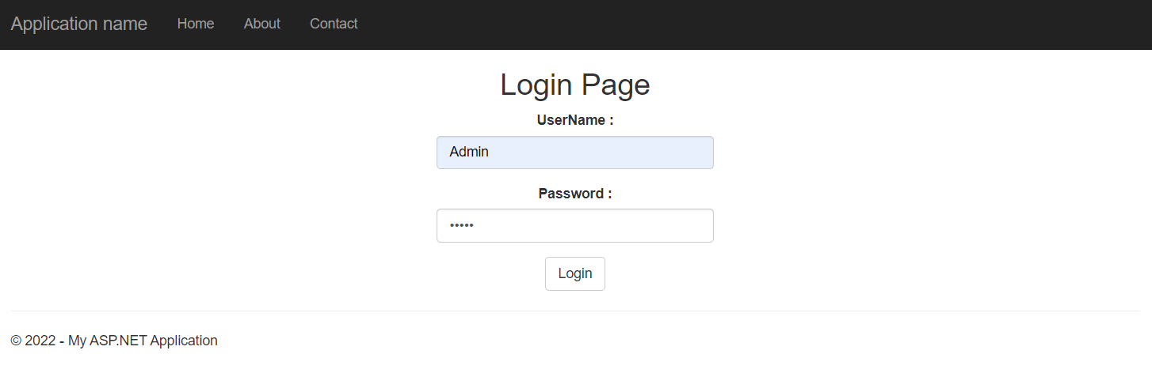

**Step 18**

After clicking the login button, a **QR code** and the **setup key** for two-factor authentication were generated, which will be used later on the mobile app for code generation.

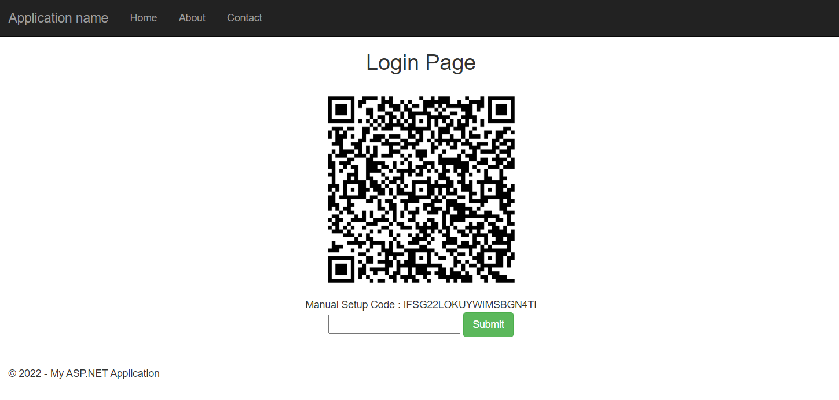

**Step 19**

Install the **Google Authenticator** app from the Play Store or [here](https://play.google.com/store/apps/details?id=com.google.android.apps.authenticator2&hl=en_IN&gl=US)on your mobile device, and open it; you have two options: scan a QR code or enter a setup key.

We scan the QR code here, so you only have one Authenticator Code, which will change after a while. Enter this code on your website.

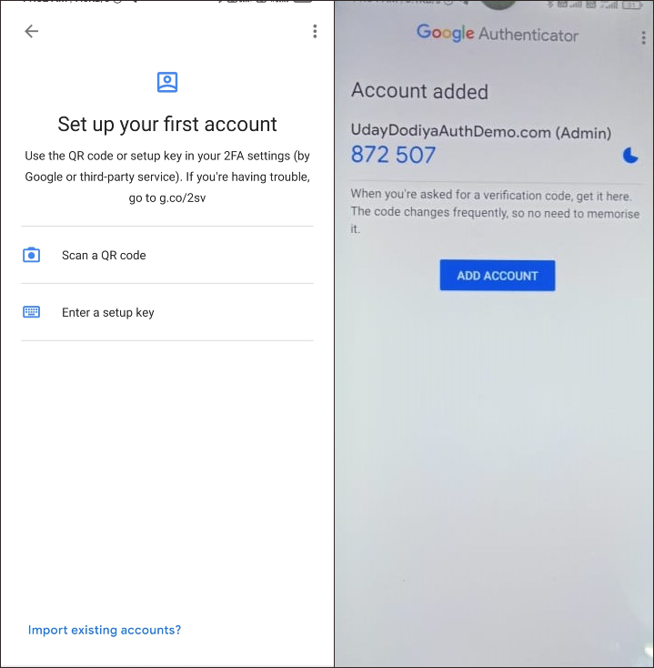

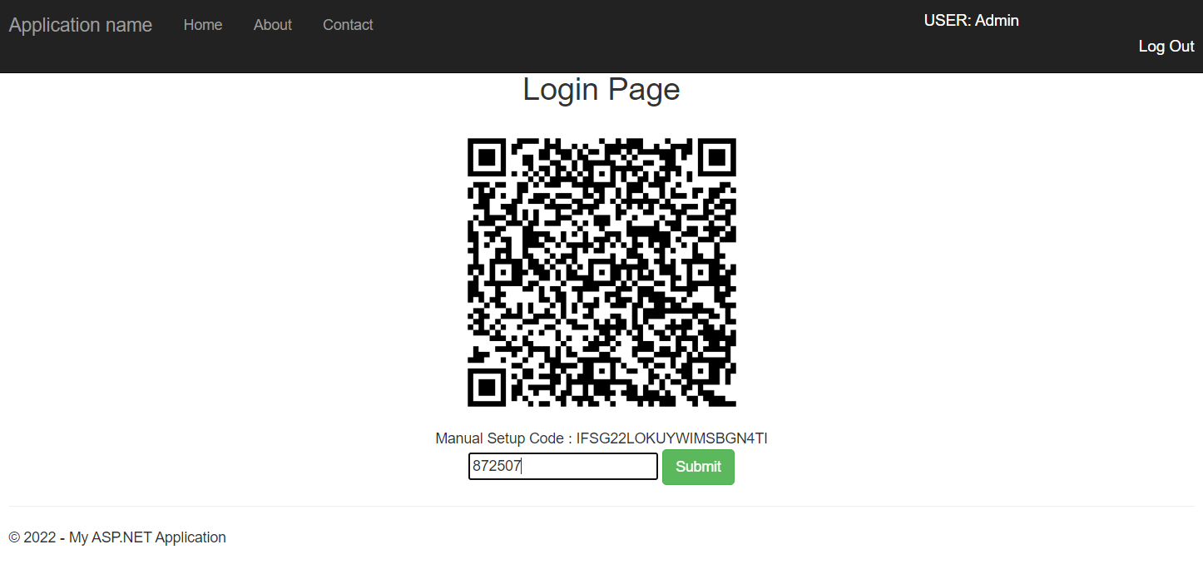

**Step 20**

If your code is correct, you will be **redirected**to your **index page** after clicking the submit button in the above screen.

